**Run Mysql sever with docker**

1. Run the command “docker pull mysql/mysql-server:latest ” to pull latest mysql server image from docker:

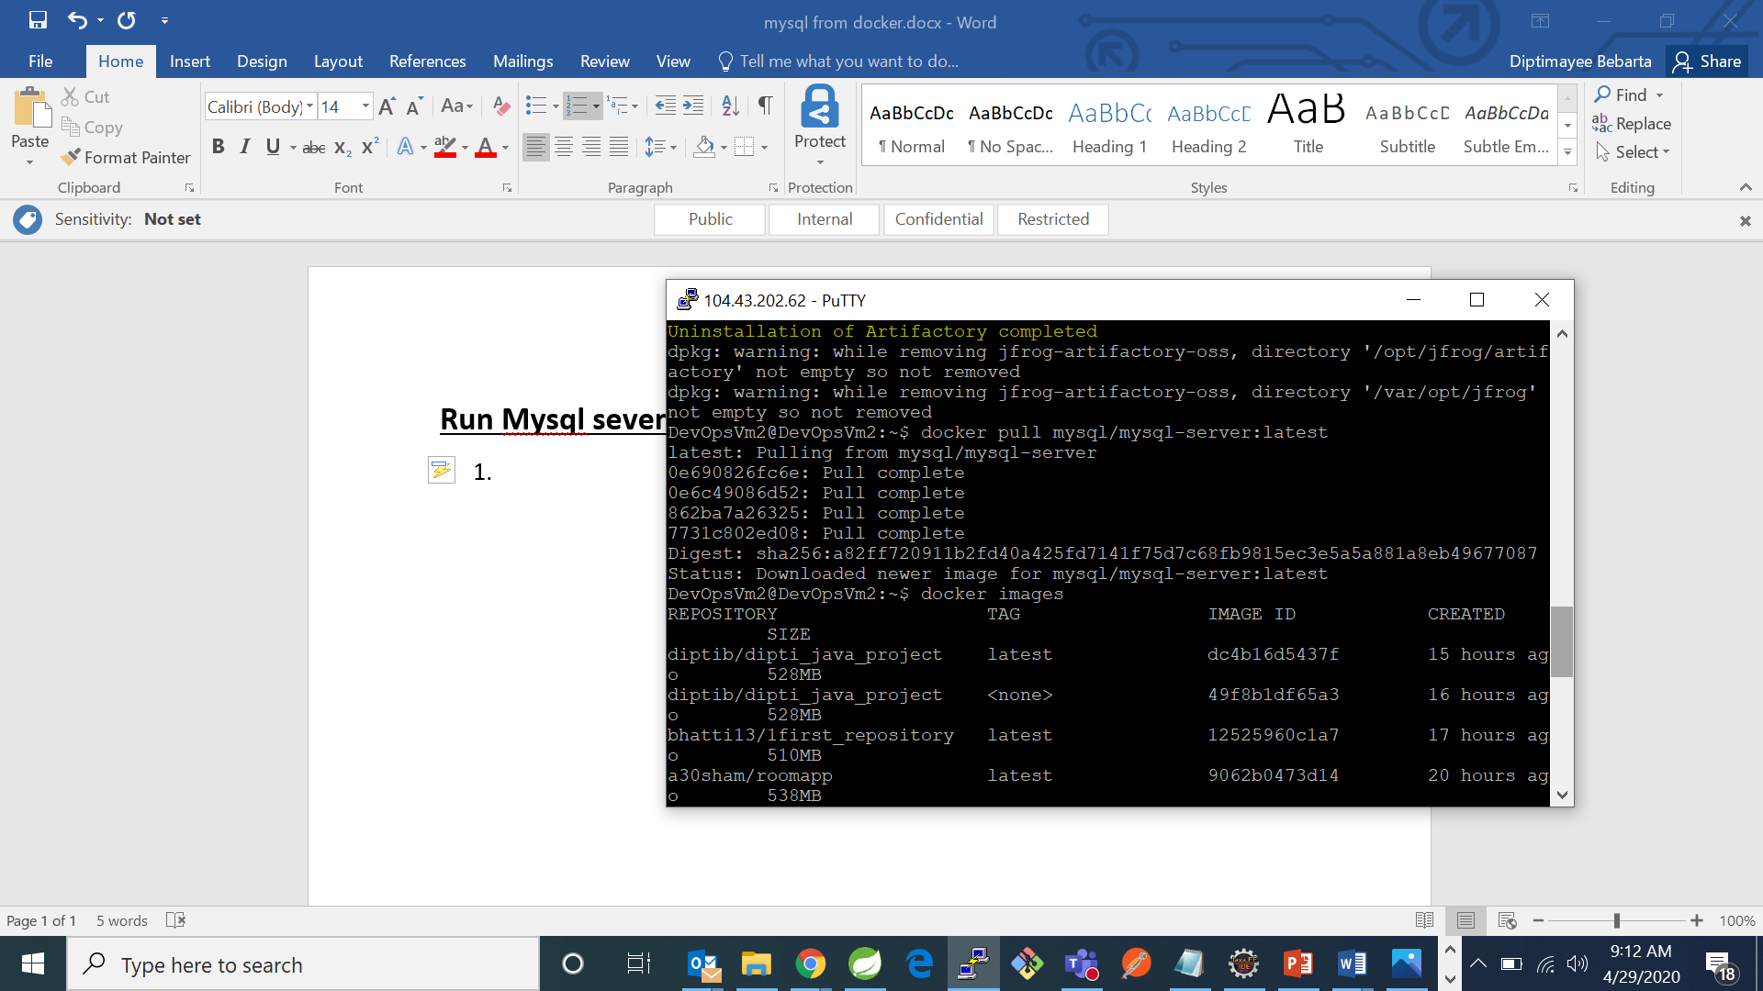

1. Now check if mysql image has been downloaded or not use command “docker images”

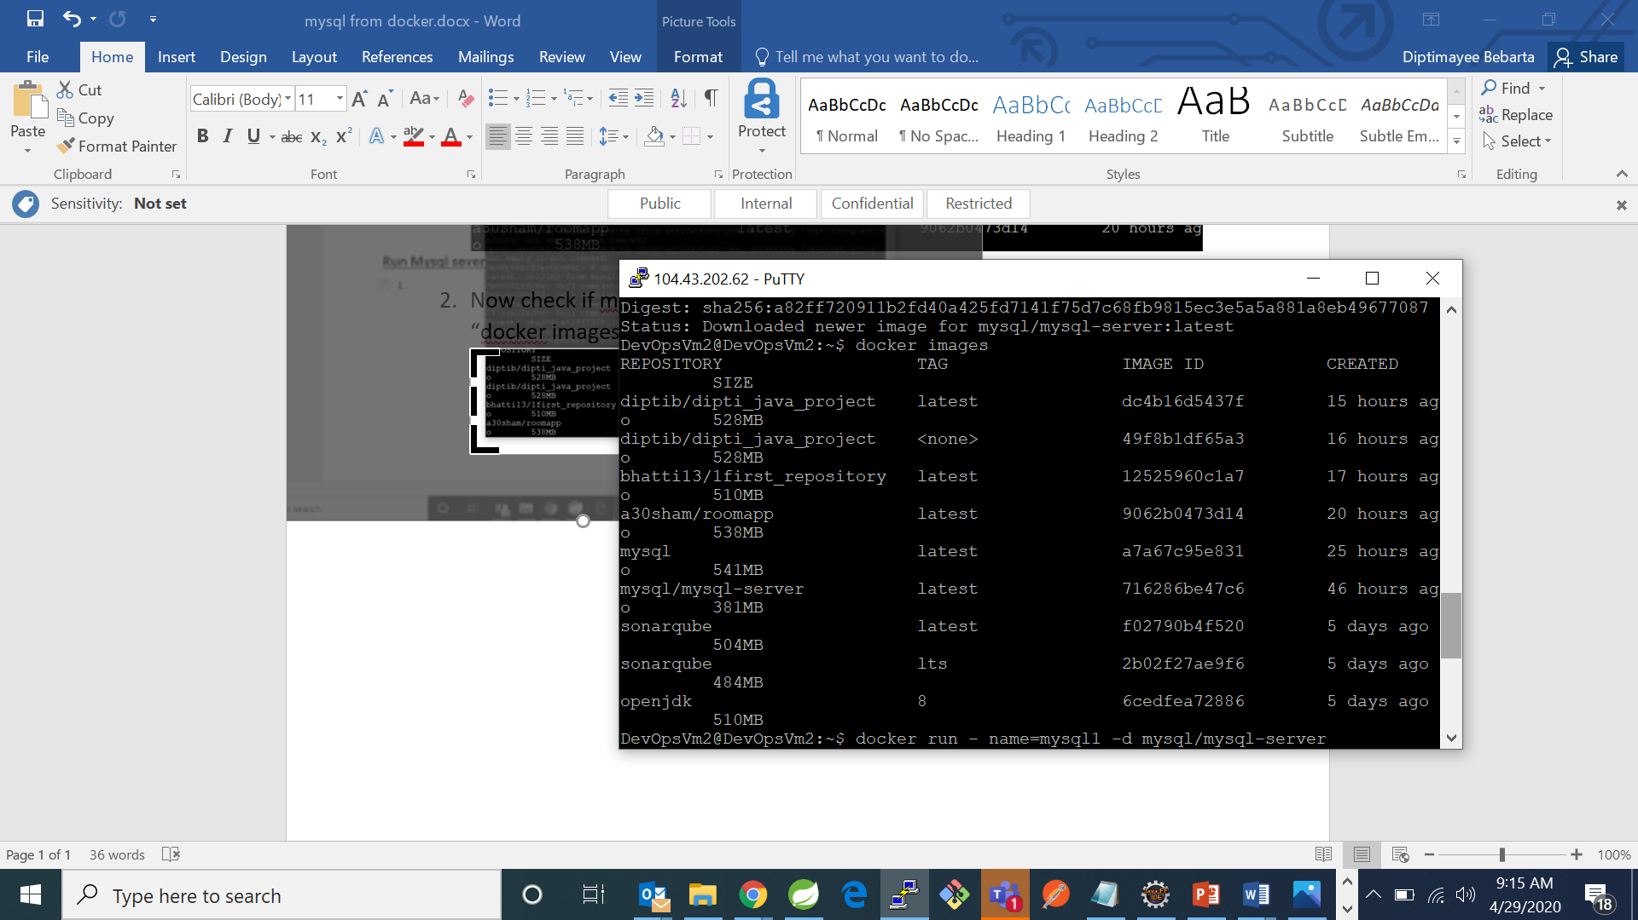

1. Now write the below command to run mysql server and assign it to a custom name mysql1:

“docker run –name=mysql1 –d mysql/mysql-server”

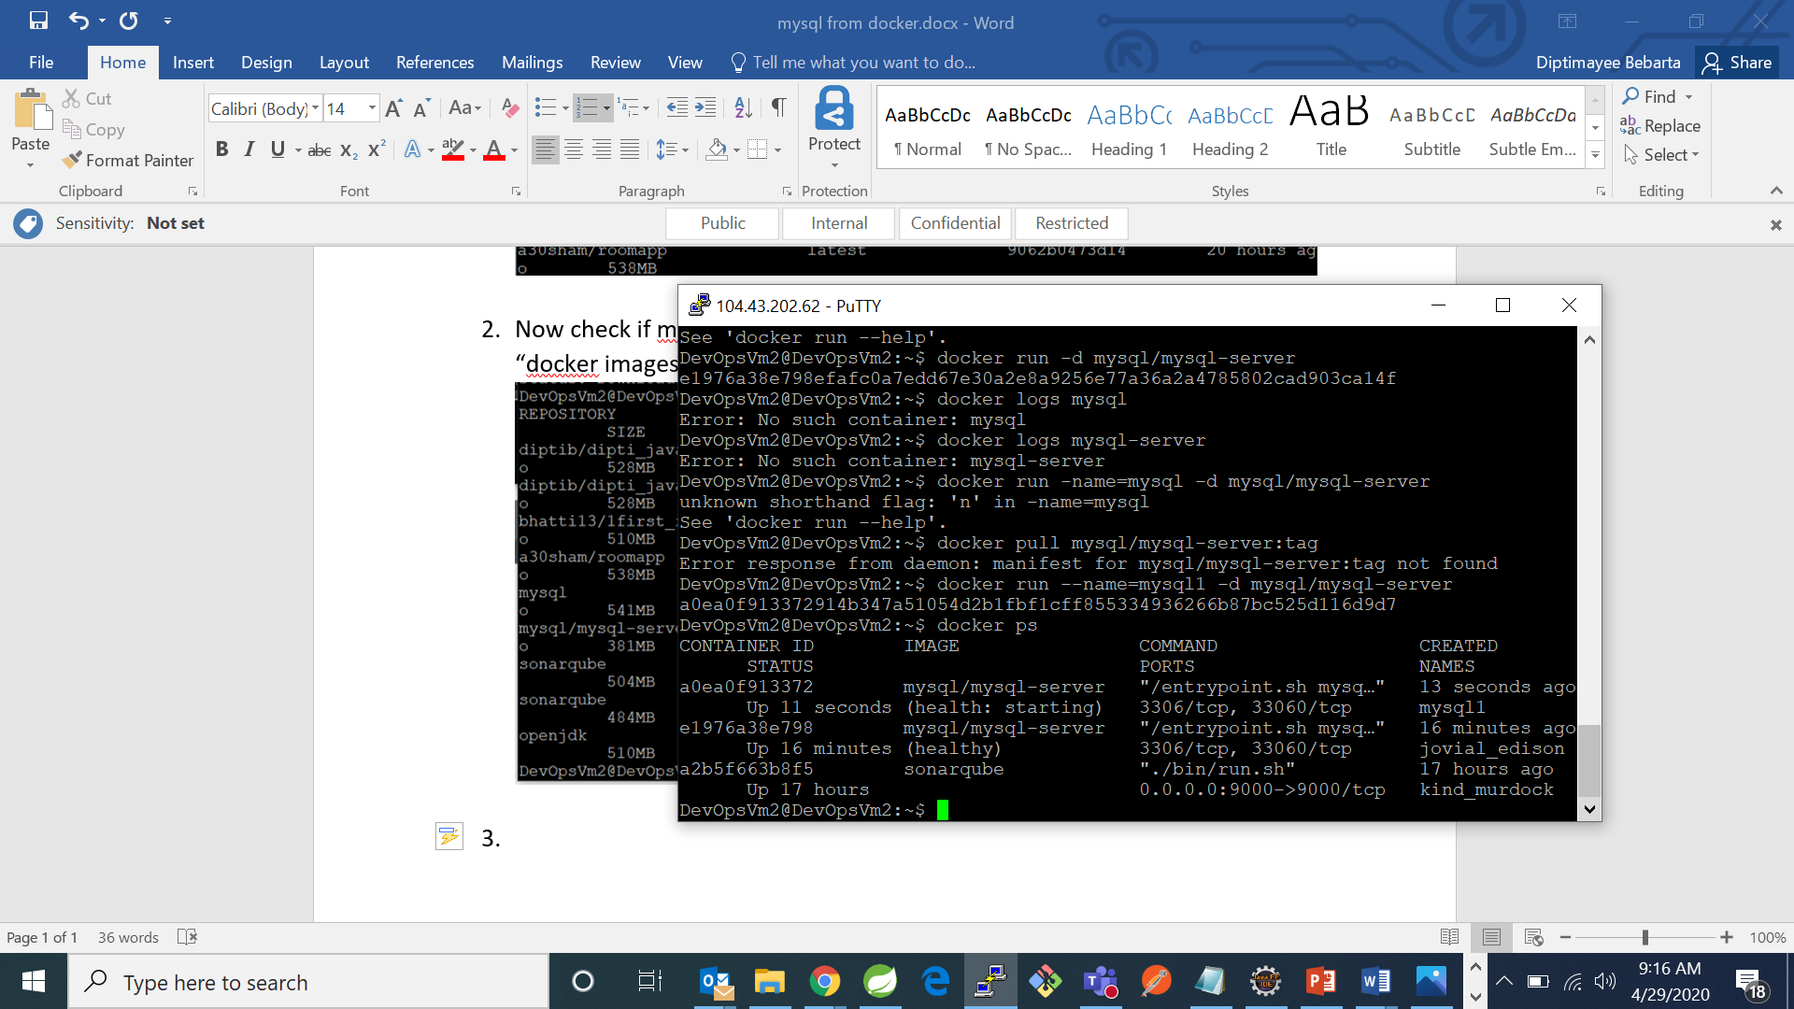

1. Now check for running containers by using command :”docker ps”

